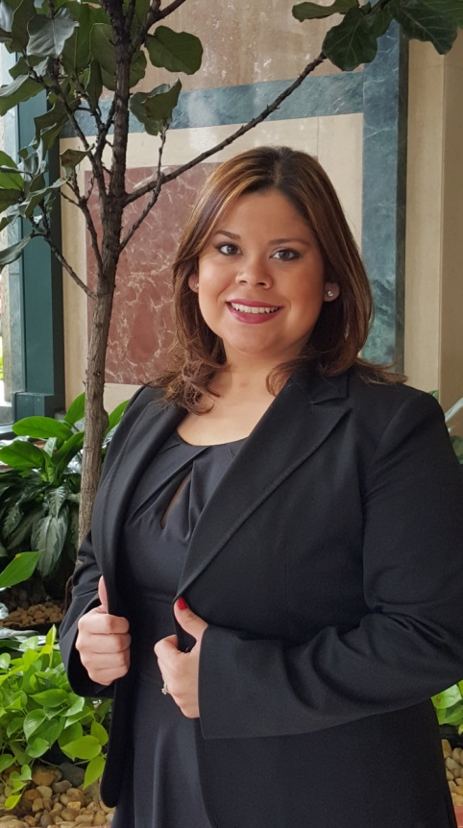

Brenda S. Rivera is an Environmental Engineer with over 7 years of experience in the civil and environmental engineering field, with a focus on environmental remediation and water infrastructure projects. Mrs. Rivera is employed by Jacobs Engineering Group, Inc. where she works on the design of water, wastewater, and stormwater infrastructure. She has served multiple key clients in the South Florida Market some included but not limited to the Seminole Tribe of Florida, Florida Department of Transportation District 4, Miami-Dade Water & Sewer Department, and City of North Miami Beach. She is the former Treasurer of the Florida Engineering Society Miami Chapter and was recently awarded Young Engineer of the Year by the FES Miami Chapter.